

NLP GROUP JOINT STOCK COMPANY

CLIENT INFORMATION SHEET

Date: October 25TH, 2023
Details of Authorized Signatory: In accordance with articles 2 through 5 of the Due Diligence Convention and the Federal Banking Commission Circular of December 1998, concerning the prevention of money laundering, and Article 305 of the Swiss Criminal Code, the following information must be supplied to banks and/or financial institutions for purposes of verification of (a) the identity and activities of the prospective investing participant and (b) the nature and origin of the funds which are to be utilized. All parties are obligated to respect professional secrecy and take all appropriate precautions to protect the confidentiality of the information it holds in respect of their activities. This legal obligation shall remain in effect at all times.

[2] | Client/Signatory Names | NHAM QUOC HUAN
 | Nationality | VIET NAM
 | Passport No | C1299799
 | Issue Date | 25/01/2016
 | Expiration Date | 22/01/2026
 | Place of Birth | 26/03/1976
 | Address | 05 Street 15 , zone 1 , BinhTrungDong Ward , ThuDuc City ― Ho Chi Minh City
[2] | Business Information
 | Business Name | NLP GROUP JOIN STOCK COMPANY (NLP GROUP)
 | Street Address | No.16, D1 Street, Mega Village Khang Dien, Phu Huu Ward, Thu Duc City, Ho Chi Minh City, Vietnam.
 | company  registration no | 0316942991
 | Bank Name | MILITARY COMMERCIAL JOINT STOCK BANK – AN PHU BRANCH
 | Bank Address | GROUND FLOOR, AN PHU BUILDING, AN PHU WARD, THU DUC CITY, HO CHI MINH CITY, VIETNAM
 | Account Name
 | Account Number | - 0000605612090 (USD)  - 797968999999 (VND)
 | Swift CODE | MSCBVNVX
 | Swift GPI CODE | MSCBVNVX
 | Bank officer | MR. LUU NGOC PHUC
 | Phone | phuc.luungoc@mbbank.com.vn
 | Email | +84 936 611 163

PASSPORT COPY

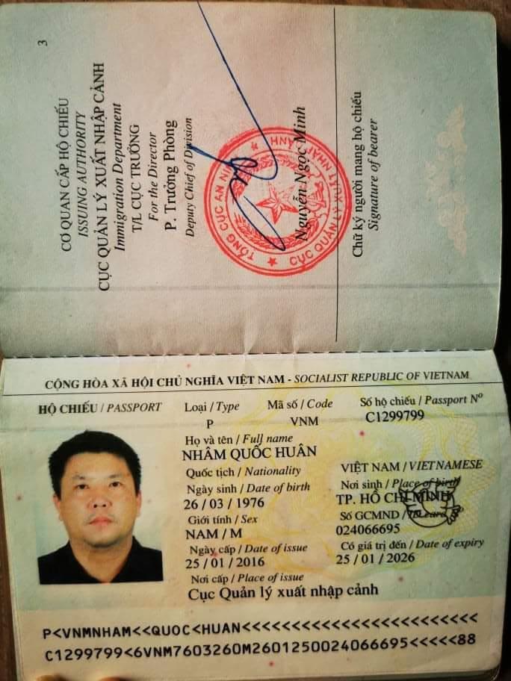

COMPANY CERTIFICATE
